Lake Area United Way  230 W. Broadway, Suite 200  Muskogee, OK 74401  918-682-1364 | 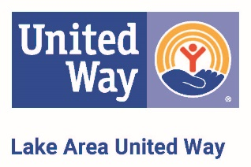
Policy No:  Title: Designations Policy | Executive Director signature:
Reviewed: December 6, 2017 | Board President signature:
Revised:

Lake Area United Way mobilizes resources to advance the economic well-being, education and health of our community. We encourage all donors to support our community impact work by donating unrestricted funds to our Community Fund.

It is recognized that sometimes individual donors may wish to make specific instructions about their gift, and LAUW will honor these instructions if they are in accordance with this Designations Policy. LAUW complies with the United Way Worldwide (UWW) Cost Deduction Standards for Membership Requirement M.

Each United Way is autonomous and independent, and thus our local policy may differ from those in other communities.

The LAUW Board of Directors has established the following policies regarding designations:

- There is no minimum Designation required for processing.

- Designations directed to partners are treated as “first dollars in” and will be part of, not in addition to, the allocation. Should designations received be in excess of the total allocation, the excess amount will be paid to the partner.

- Designations will only be honored to any United Way or to any non-profit organization which is registered by law for charitable 501(c)(3) tax status.

- LAUW will honor designations to individual programs within an organization and will note this on the designation payout letter.

- LAUW is unable to process designations on behalf of an individual raising funds for another nonprofit organization through a pledge drive.

- Donors designate at their discretion. LAUW does not review or attest to the accountability and/or service provision of organizations who have not participated in our eligibility review process.

- Non-Community Partners and Other United Way Designations will be paid out quarterly, starting July 1st of the year following the campaign. Final 4th quarter payment may be less due to uncollected pledges. Designations of $1000 or under will be paid in full July 31st following the campaign year.

- All agencies receiving designation payments will be required to submit an annual statement of compliance with the Patriot Act.

- LAUW Board of Directors reserves the right to deny gifts designated to LAUW such as property.

- LAUW Board of Directors reserves the right to deny donations or gifts from any organization that is not in line with the LAUW mission, vision or goals.

